**Name: lareb Zubair**

**Enrollment no: BSCS/3-22/003**

**Subject: web engineering and technologies**

**Project name: My quiz website**

**Date: 14-10-2024**

**Home page.html**

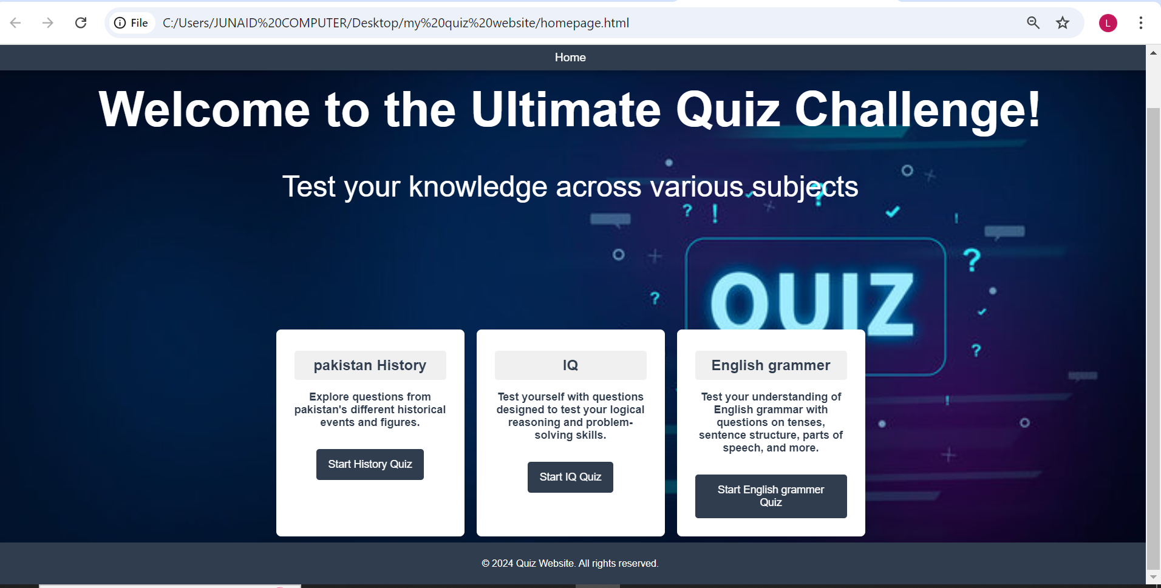

**Pakistan history_quiz.html**

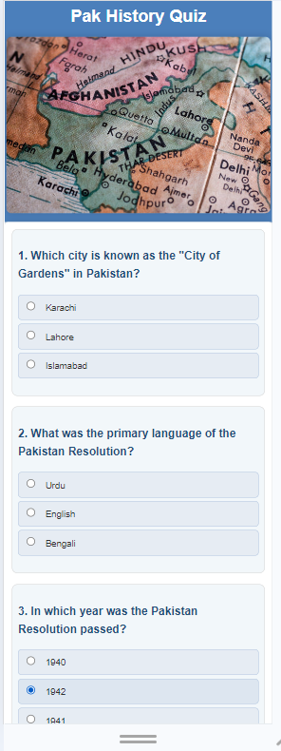

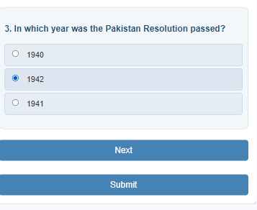

**IQ­_quiz.html**

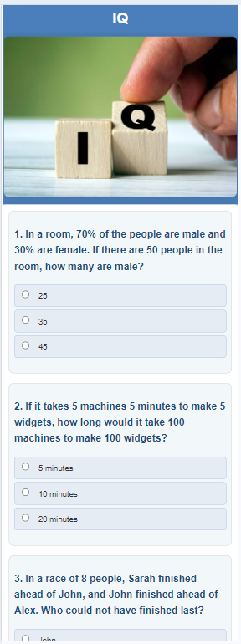

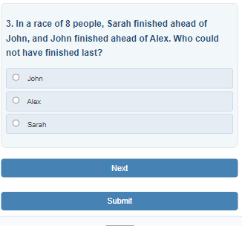

**English _quiz.html**

